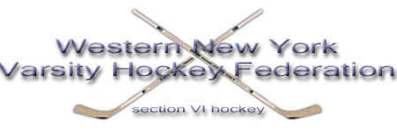
POST-SEASON REPORT
SECTION VI ICE HOCKEY 2007-08
Chairperson: Brett Banker

- Two Section VI public schools advanced all the way to Utica to play in the state Frozen Four. Lancaster (Division I) and Sweet Home (Division II) represented us well, both losing close battles in the state semi-finals.

- St. Joseph’s Collegiate captured their 6th straight NYS Catholic High School Championship.

- All State Teams as selected by the NYS Hockey Coaches Association
Division I 2nd Team Nick Fronczak Wms North
Hon Mention Mark Goulding St. Joes
Joe Karl Lancaster
Division II Hon Mention Ryan Marko Sweet Home

- Frozen Four All-Tournament Team-no representatives this year

- Frozen Four Sportsmanship
Division I Ken Wojnowski Lancaster
Division II Rich Beaudet Sweet Home

- Section VI Sportsmanship Teams & Individuals
Division I Frontier Matt O’Donnell
Division II Niagara Falls Tom Hanna

- Regular Season Federation Champions
Large Schools St. Joseph’s Collegiate
Small Schools Timon St. Jude

- Federation Playoff Champions
Large Schools St. Joseph’s over Wms-North
Small Schools Sweet Home over Timon

- NYSPHSAA SCHOLAR ATHLETE TEAM AWARDS
Niagara Falls 95 * 3rd in the state
Clarence 94 *6th in state
Williamsville East 94 *8th in state
Williamsville North 93 *12th in state
Frontier 90.7 *49th in state
Kenmore East 90.5 *52nd in state

