Athletic Council Meeting January 16, 2008 – Agenda Item 11.0

2007 POST-SEASON REPORT
SECTION VI GIRLS SWIMMING
Chairperson: Bruce Johnson

January 9, 2008

The fall season of girl’s swimming and diving in 2007, culminated with Section VI busing thirty –two swimmers and divers to the state championship meet on Long Island. Our lone state champion was again Casey Matthews from Williamsville North, who won the 1 meter diving event for the third time in the last four years.

In all, the season ran very smoothly. Our leagues and league championship meets were run without trouble and the Section VI meet also came off without a hitch.

The season marked the first time in four years that we were forced to travel to our state championship meet and that did create some unforeseen difficulties on my part. In the future, we will work to ensure that all swimmers travel to the meet site on transportation provided by the section. I will also make sure that I am up to speed on the sectional policy in this regard.

The financial report for our expenses and revenue has already been turned into the section. We again brought in almost $7,000.00 in admission, program, t-shirt revenue to the section.

As we look forward to another season in 2008, our committee will continue to ensure you that we will run a more efficient sport and accountable program.

Thank you for your continued support of our sport as we try to provide the best program possible for the student athletes of Section VI

Sincerely,
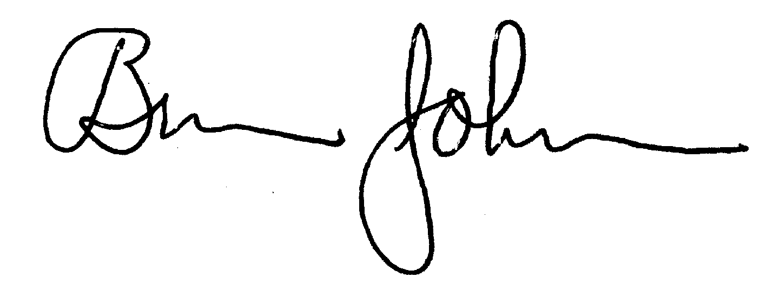

Bruce Johnson

