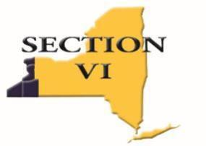

## Mark DiFilippo, Executive Director CAA

[**mdifilippo@e1b.org**](mailto:mdifilippo@e1b.org)

355 Harlem Road, West Seneca, NY 14224 Phone: 716-821-7092

# SECTION VI

# ADPRO SPORTS / LEGENDS

# ALL-WESTERN NEW YORK SCHOLAR-ATHLETE

**Fall 2024**

January 24, 2025

Congratulations! It is with great pride and pleasure that we notify you that you have been selected to the 2024-2025 Section VI ADPRO SPORTS / LEGENDS Scholar-Athlete All-Western New York Scholar-Athlete team. The application for this recognition was submitted to our committee by your school district.

Your information has been submitted to the Buffalo News. Your name will be listed in the newspaper shortly. Once we know the exact date of printing, we will reach out to your school’s Athletic Director.

This is an outstanding accomplishment for you, your team, your school, and your community to share. You have distinguished yourself academically and athletically. You represent the finest qualities of a student-athlete and citizen.

Again, congratulations on your accomplishments!

## Sincerely,

**The All-Western New York Scholar-Athlete Selection Committee**

cc: Athletic Director