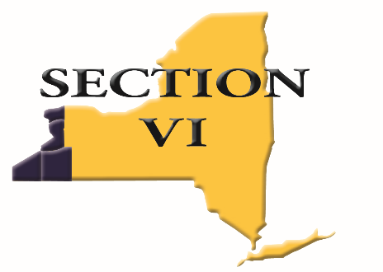

355 Harlem Road ∙ West Seneca, NY 14224

Mark DiFilippo, Executive Director

[mdifilippo@e1b.org](mailto:mdifilippo@e1b.org) ∙ Phone: 716-821-7092 ∙ Fax: 716-821-7352

**NOTIFICATION OF OPTING OUT OF**

**SECTION VI TRANSPORTATION TO STATE COMPETITION**

**NOTE:**

**This form must be submitted to the Sportchair by the end of the day at the sectional meet OR the date specified in the sport handbook. Once this form is submitted, the decision is final.**

The coach and athlete(s) listed below are opting out of traveling to state competition on the transportation that is provided by Section VI. We fully understand that by doing so, our district may be responsible for some or all expenses on the trip. In addition, as per the Section VI Policy on Travel to State Competition posted on the Section VI website*, we are aware of the following:

* + A school that opt-outs of Section transportation will be responsible for arranging their own lodging and meals.
* The request to opt-out of travel on the Section VI bus must be submitted in writing to the Sportchair and the Section VI office by the date specified in the sport handbook.
* The school must submit all required release forms to the Sportchair by the specified date.
* The school must arrange for the athlete to rendezvous with the Sportchair (or designee) at a pre-designated time and place prior to the competition.

|  |  |
| --- | --- |
| School: |  |
| Coach: |  |
| Sport: |  |
| Athlete(s): |  |
|  | |
|  | |
|  | |
|  | |
|  | |
|  | |
|  | |

Print name Signature

|  |  |  |
| --- | --- | --- |
| Superintendent: |  |  |
| Principal: |  |  |
| Athletic Director: |  |  |
| Date: |  | |