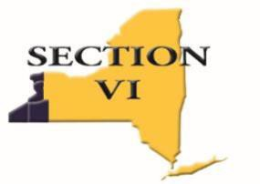

## Mark DiFilippo, Executive Director CAA

[**mdifilippo@e1b.org**](mailto:mdifilippo@e1b.org)

355 Harlem Road, West Seneca, NY 14224 Phone: 716-821-7092

# ADPRO SPORTS / SECTION VI SCHOLAR-ATHLETE ALL-WESTERN NEW YORK

**Fall 2023**

January 3, 2024

As you are aware, you have been nominated for the ADPRO Sports / Section VI Scholar- Athlete All-Western New York team. Although you have not been selected for the team, we are writing to applaud you for your nomination. Recommendation for this honor is an outstanding accomplishment, for which you, your team, your school, and your community should be

proud. You have distinguished yourself academically and athletically and represent the finest qualities of a student-athlete and citizen.

Again, congratulations on your accomplishments and the best of luck to you in future endeavors!

cc: Athletic Director

## Sincerely,

**The All-Western New York Scholar-Athlete Selection Committee**