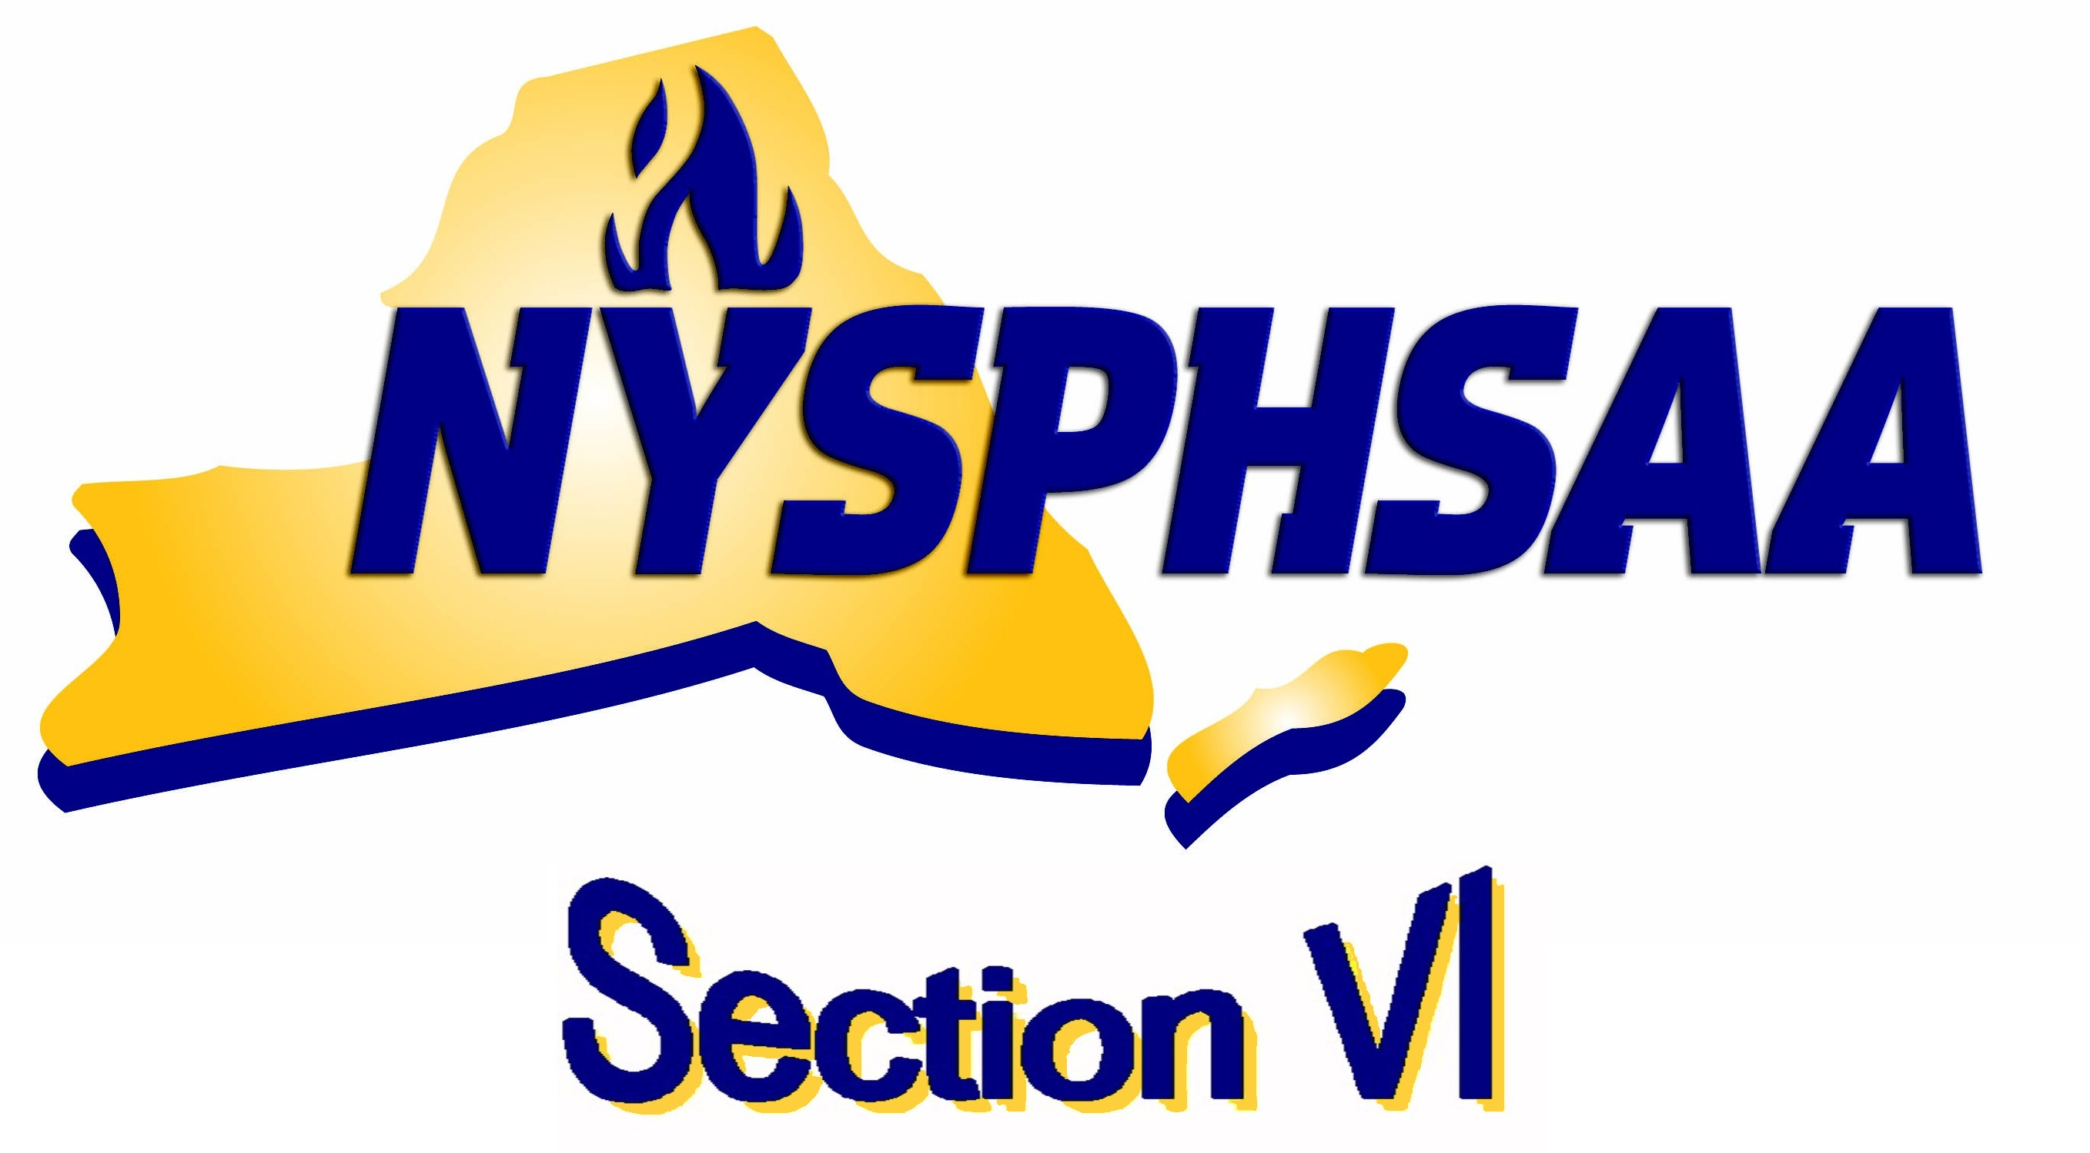
SECTION VI COACHES SPORTSMANSHIP AWARD
NOMINATION FORM

A coach selected to receive this award will be a coach who treats all teammates, opponents, coaches, and officials with the utmost respect and within the standards set by the coach’s code of conduct. Administrators, coaches, or league chairmen are encouraged to nominate a coach who illustrates or captures the spirit of “sportsmanship” and deserves recognition.

LEAGUE: DIVISION: SPORT:

Coach’s name: # years coaching the sport:
School:

Home Address:
Town: Zip:

Person submitting the nomination Date of nomination:
School: Phone:

Describe what has this coach done that is above and beyond the basic expectations for a coach to illustrate sportsmanship:

Nominator Signature: _______________________________________________
Check here if transmitted electronically.
Please enter your e-mail address as verification of signature:

Submit this nomination form to your League President or Secretary prior to the next league meeting. The League’s selection of the winner of this award is due to the Sportsmanship Chairperson Doug Beetow by mid-June.

Doug Ames, (716) 544-5473 dougames6631@gmail.com
Jim Graczyk, (716) 982-5204 jglcj62@yahoo.com

SPORTSMANSHIP………..…IT BEGINS WITH YOU!

