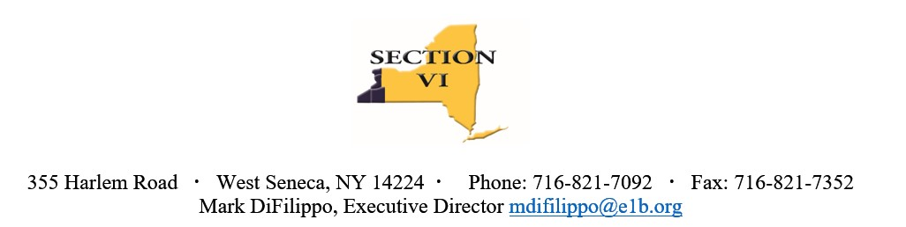

NOTICE OF VACANCY

Posting Date: November 15, 2023

Starting Date: January 5, 2024

Position Title: Section VI Principals’ Representative

Job Description Section VI Principals’ Representative

Term:
The Section VI Principal Representative is elected to a four-year term. (This appointment will be to fulfill the current term which ends August 2024)

Qualifications:
Any active Principal, in good standing, of a Section VI member school may serve.

Duties:
- Represent Section VI at the NYSPHSAA Central Committee meetings.
- Attend Monthly Section VI Executive Committee and Bi-monthly Athletic Council Meetings.
- Report pertinent information from the NYSPHSAA Central Committee meetings to the Section VI Executive Committee and Athletic Council.
- Provide recommendations for action at the NYSPHSAA Central Committee meetings.
- Represent All Section VI Principals at Section VI Executive Committee and Athletic Council meetings.
As an athletic council voting member:
- Assist with the supervision and formulation of policies for sectional athletic activities.
- Assist with the review of member school’s infractions as brought forth by the appropriate committee.
- Assist with approving the annual budgets submitted by the Section VI Finance Committee.
- Responsible for obtaining an alternate if unable to attend a meeting of the Section VI Executive Committee or Athletic Council.
- Communicate relevant information/updates on current issues to Principals.

Candidates must send a letter of interest and professional resume to:

Mark DiFilippo, Executive Director
Section VI, NYSPHSAA, Inc.
355 Harlem Road
West Seneca, NY 14224
mdifilippo@e1b.org

Applications will be accepted through January 5, 2024

