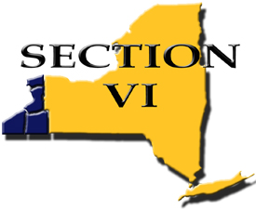

News Announcement

For Immediate Release

August 16, 2016

Contact Information:

Timm Slade, Executive Director

Phone 716-821-7092

[tslade@e1b.org](mailto:tslade@e1b.org)

**3rd Annual Section VI Hall of Fame**

Section VI (NYSPHSAA) proudly announces its Hall of Fame, Class of 2016:

Jeff Anastasia Coach Olean High School

Harvey Austin* Athlete/Coach Emerson High School

Jerry Baldelli Administrator Frontier High School/Section VI

Tim Bergan Coach Ellicottville Central Schools

Jehuu Caulcrick Athlete Clymer Central Schools

Jim Conley Admin/Coach/Contributor/Official Newfane Central Schools

Dick Gallagher Contributor Section VI

Don Gilbert Athlete/Coach Bennett High School

Robert Hettler* Coach Amherst Central Schools

Dave Hollins Athlete Orchard Park Central Schools

Wally Huckno Coach Jamestown High School

Bob Lanier Athlete Bennett High School

Larry Lash Coach Wilson Central Schools

Warren Spahn* Athlete South Park High School

Larry Veronica Coach Bennett High School

Mark Ward Administrator Ellicottville Central Schools

(*posthumous)

The Section VI Hall of Fame was established to honor and recognize those, within its organization, who excelled in their roles as Athletes, Administrators, Coaches, Officials, or Contributors who have provided meritorious service.

The commitment to athletics made by those who comprise the Hall of Fame has contributed to the promotion, continuation, and development of programs within Section VI.

The Class of 2016 induction ceremony is scheduled for Friday, December 9, 2016 at The Columns Banquets, located in Elma, NY. The evening will commence at 5:30 pm with a cash bar and dinner, followed by the induction ceremony. Dinner reservations are $30 per individual. No advance payment is necessary, but reservations must be made by November 23, 2016 to: [section6@e1b.org](mailto:section6@e1b.org) or Pauline Turski at (716) 821-7581.